Ownership Certificate

To Whom It May Concern

This is to certify that the following equipment mentioned below are the sole owned by
Branch of Sudhir Gensets LTD.

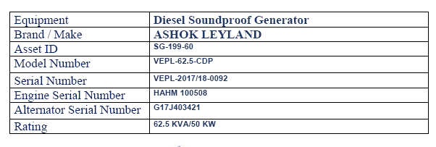

Mansoor Ali
Branch Manager
Branch of Sudhir Gensets LTD. Co
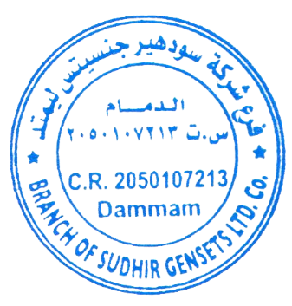
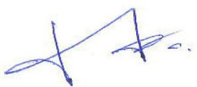
Dammam - KSA

